Example of/from the Economics and accounting test Between 40 and 50 problems to solve like:
Problem 1:
Inflation is a …
- large, one-time fall in the price level.
- minor change in the price level.
- process of falling prices.
- process of rising prices.

Problem 2:
If a decrease in the price of good A increases the quantity demanded of good B, then
- B is a substitute for A, but A is a complement of B.
- A and B are complements.
- A is a substitute for B, but B is a complement of A.
- A and B are substitutes.

Problem 3:

Refer to the figure 6.1 below about the demand and supply on the housing market:

If a rent ceiling of $600 is implemented then:

The rent paid by tenants is $600 and the housing surplus is 20.000 houses

The rent paid by tenants is $300 and the housing shortage is 20.000 houses

The rent paid by tenants is $600 and there is no housing shortage or surplus.

The rent paid by tenants is $450 and there is no housing shortage or surplus.

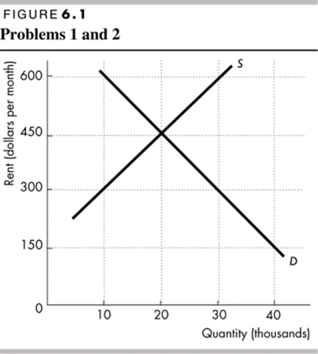

Problem 4:
For Dye Company, at a sales level of 5,000 units, sales is $75,000, variable expenses total $40,000, and fixed expenses are
$21,000. What is the contribution margin per unit?
- $2.80
- $15.00
- $8.00
- $7.00

Answer sheet:
Problem 1: (d) process of rising prices.
Problem 2: (b) A and B are complements.
Problem 3: (d) the rent is $450 and there is no housing shortage or surplus as it is a non- binding rent ceiling
Problem 4: (d) $7.00.

